Elite Travel Management
Elite - A new travel management service in the city is wants to design a web page which will enable their customers to furnish details pertaining to their travel along with preferred activities at the destination - to build a custom-package.
The following are the screen-shots pertaining to Elite Travel Management.
id=personal _info

id=preferences_info

id=travel_info

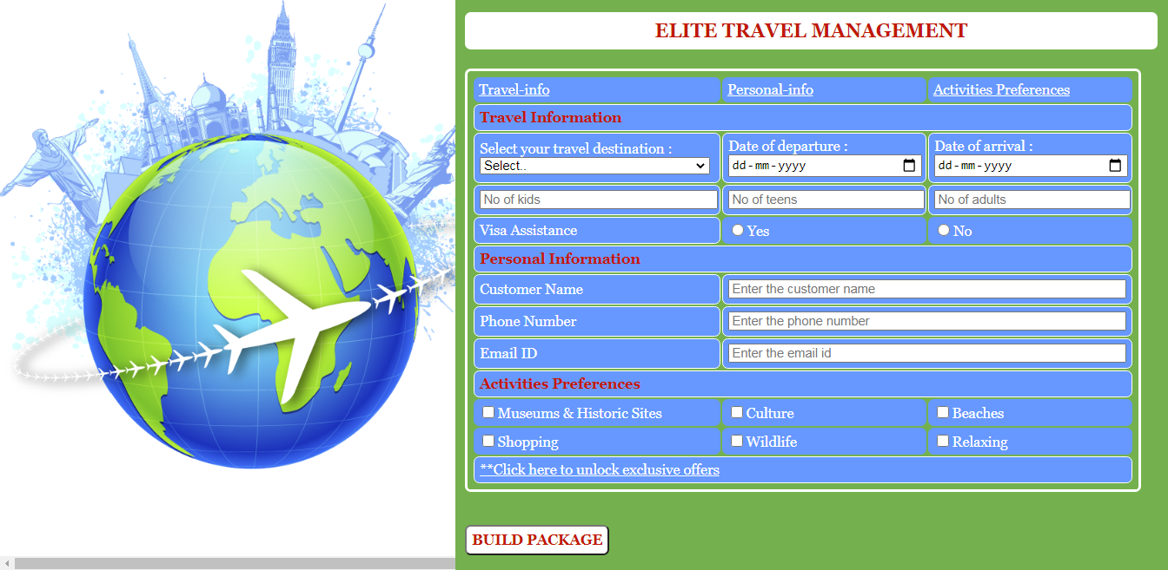
id=adults
id=dateofarrival

id=personal

id=cname

id=email
id=phno
id=preferences

id=offers

id=travel

id=destination

id=culture

id=museumsAndHistoricSites

id=beaches

id=kids

id=submit

id=no

id=image

id=teens

id=dateofdeparture

id=yes
id=shopping

id=wildlife

id=relaxing
id=octroi

On mouse over the component that says - unlock exclusive offers :
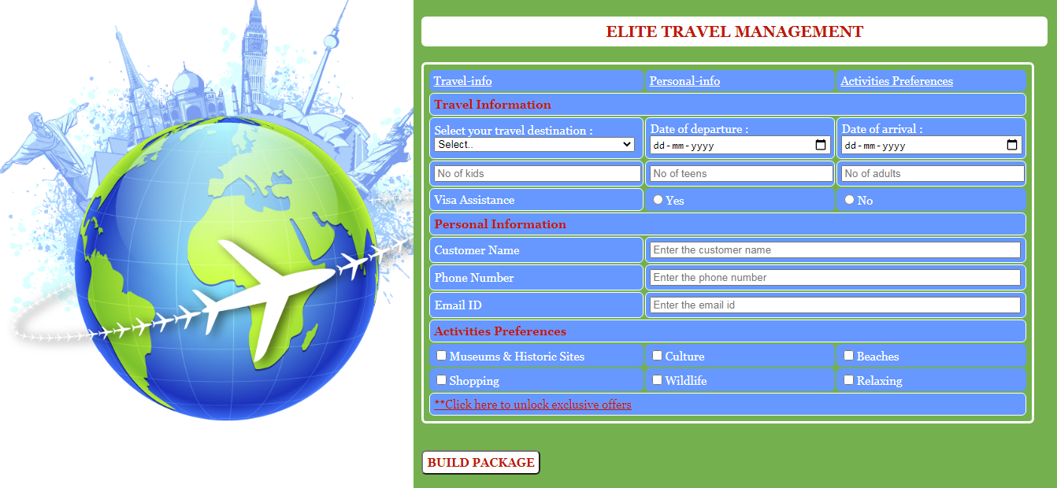
On mouse over the submit component :
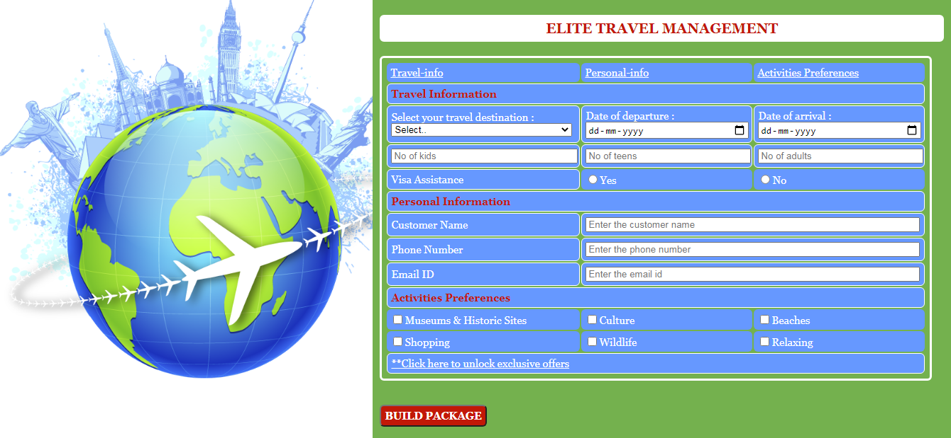

Use the Label Name and the Component Id as given. The Component Id can be given in any case (Upper case or Lower case or Mixed case). All the necessary attributes for the Components should be given.
The Component Id should be specified for each HTML Component. If the Component Id is not provided for a HTML component, marks will not be provided for this component.
All Tags, Elements and Attributes should conform to HTML5 Standards. All fields except website link are mandatory.
Provide the details as given in the table below.
Req. # | Req. Name | Req. Description
1 | Design a Web page “Elite Travel Management” with the specified fields. | NOTE: The text highlighted in bold in the Description needs to be implemented in the code to complete the web page design.
  Label Name | Component Id  (Specify it for the “id” attribute) | Description
   | Use ”travel_info”, “personal_info” and “preferences_info” as the ids for Travel_info, Personal_info and Activities Preferences components respectively. | Specify 3 hrefs ( each for the corresponding anchor tag ) holding 3 hyperlinks.  "#travel" ( links to Travel Information )  "#personal" ( links to Personal Information )  "#preferences" ( links to Activities Preferences )
  Travel Information | travel | To get referred by href of anchor tag with id “travel_info”
   | destination | To select the destination.  Design Constraints  Use drop down with ”Select..”, ”London”, “Canada” , “Mauritius”and “Switzerland” as option values.  The field is mandatory.
   | dateofdeparture | To enter the date of departure.  Design Constraints:  Provide the correct input type to make this component accept date.  The field is mandatory.
   | dateofarrival | To enter the date of arrival.  Design Constraints:  Provide the correct input type to make this component accept date.  The field is mandatory.
   | kids | To enter the no of kids.  Design Constraints:  The text “No of kids” should appear by default.  Provide the correct input type to make this component accept number.  The field is mandatory.
   | teens | To enter the no of teens.  Design Constraints:  The text “No of teens” should appear by default.  Provide the correct input type to make this component accept number.  The field is mandatory.
   | adults | To enter the no of adults.  Design Constraints:  The text “No of adults” should appear by default.  Provide the correct input type to make this component accept number.  The field is mandatory.
  Visa Assistance | Use ”yes” and “no” as the component ids for the radio buttons. | To select if visa assistance is required or not.  Design Constraints:  The name of the radio buttons pertaining to yes and no is ‘visa’.  Both components are mandatory.
  Personal Information | personal | To get referred by href of anchor tag with id “personal_info”
  Customer Name | cname | To enter the customer name.  Design Constraints:  The text “Enter the customer name” should appear by default.  It should contain only alphabets and spaces.  The field is mandatory.
  Phone Number | phno | To enter the phone number.  Design Constraints:  The text “Enter the phone number” should appear by default.  Tip:  Use type=”tel”or Use type=”text” .  Use “pattern” attribute to accept the 10-digit mobile number to start with either of the following numbers: 7,8 or 9.  The field is mandatory.
  Email ID | email | To enter the email id. .  Design Constraints:  The text “Enter the email id” should appear by default.  Provide the correct input type to make this component accept only an email id.  It should be mandatory.
  Activities Preferences | preferences | To get referred by href of anchor tag with id “preferences_info”
   | Use ”museumsAndHistoricSites”, “culture”, “beaches”, “shopping”, ”wildlife” and “relaxing”as the component ids for the check box options. | To select the activities preferred at the destination.  Design Constraints:  The name of checkboxes pertaining to all the options is ‘charges’.
   | offers | Specify a href holding the hyperlink to :  "#submit"
   | submit | The input type button must be used, with value “BUILD PACKAGE”.  It is clickable but has no action associated with it.
2 | Apply the mentioned styles using CSS to the components | STYLING WITH CLASS SELECTORS  - Set the style left as 0 in the class left.  - Set the following styles to the class right.  Set right as 0 and background-color as #74B14E.  Its width must be 60% and padding must be 10px.  - Set the color as #FFFFFF in the class b.  - Set the following styles to the class c.  Set color as #C21807 and font-size as 15px.  Its font-family must be Georgia and font-weight must be bold.  STYLING WITH ID SELECTOR  - Set width and height of image (id of img tag) as 120% and 90% respectively.  STYLING WITH ELEMENT SELECTORS  - HEADING should be specified using <h3> tag.  The text-align must be center and font-size must be 20px.  The font-family of the text must be Georgia.  The border-radius must be 6px and padding must be 5px.  - The border-spacing of TABLE and HEADER must be 2px and width must be 97%.  - The color of TD must be #FFFFFF and the background-color must be #6698FF. The border-spacing must be 5px.  STYLING WITH ELEMEMT & ID SELECTORS  - The SUBMIT button’s (identified by id‘submit’) text and the HEADER must be colored with #C21807.  Its font-weight must be bold and its background-color must be #FFFFFF.  - The SUBMIT button (identified by id‘submit’), TABLE & TD must have the following styles.  Their font-size and font-family must be 15px and Georgia respectively.  The border radius must be 6px and padding must be 5px.  Note: Fill in the style tag so as to have the given styles applied to the components.  (Do not use Inline CSS)

